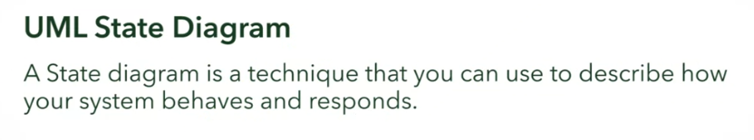

Sample

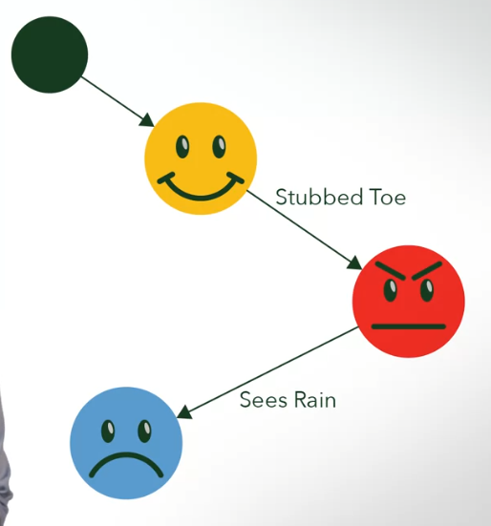

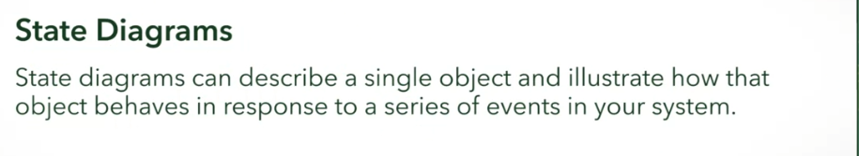

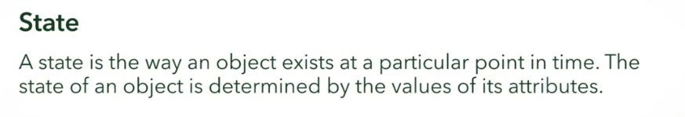

Think of an egg. What kind of states could an egg have?

You could have thought of many states! Perhaps you came up with: Raw, HardBoiled, Fried, Spoiled.

All of these could be represented with a state diagram, and there may be activities and attributes associated with each state!

UML State Diagram Parts

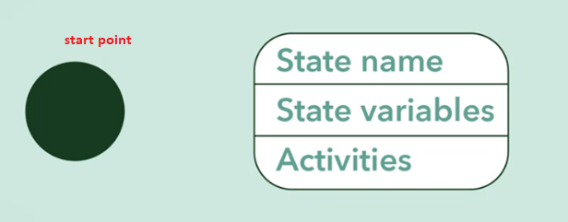

State Name

* Name of the state
  + Eg:
    - Idle
    - Reverse
    - Full

State Variables

* Data relevant to the state name
  + Which is the object that has the state name

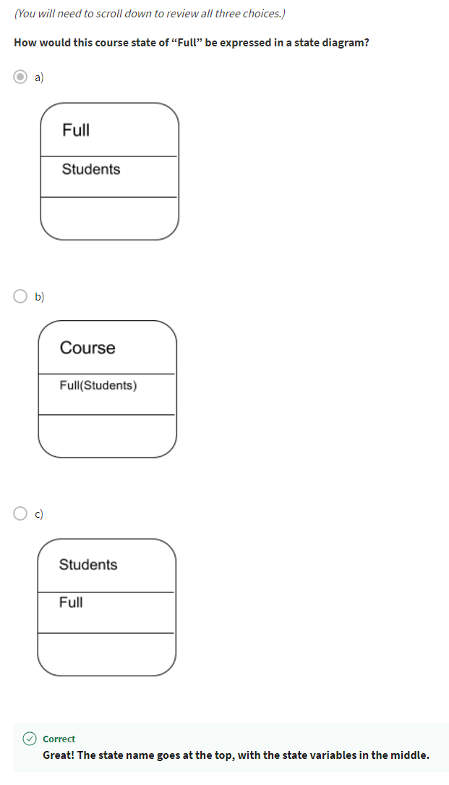

Activities

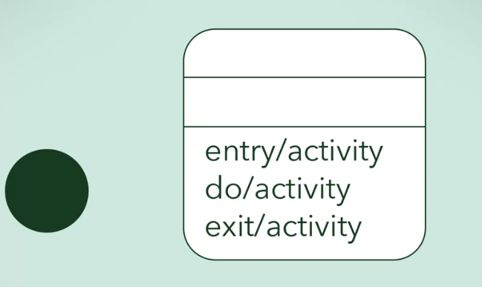

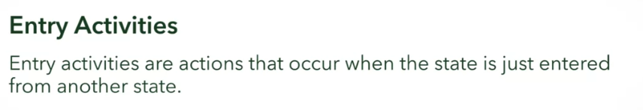

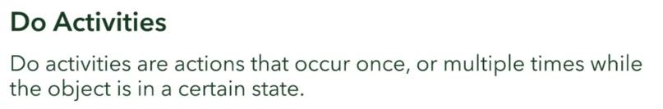

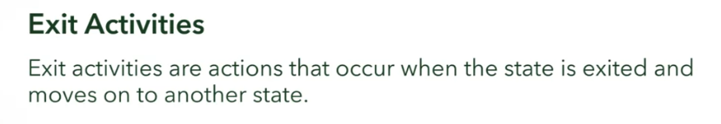

Example of activity: Ringing Alarm Clock

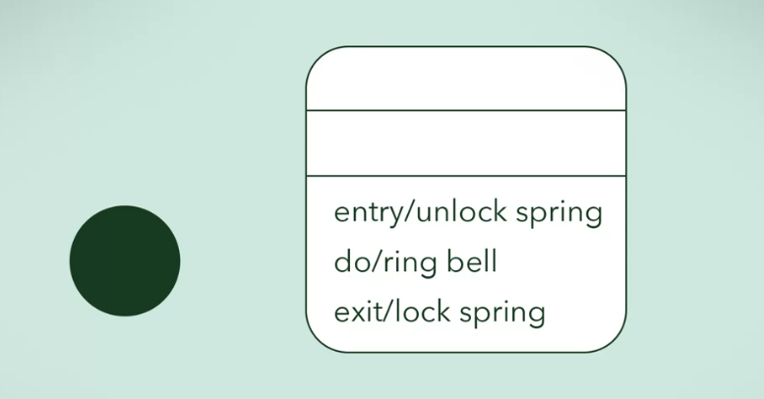

Transitions

* Events that could change the states

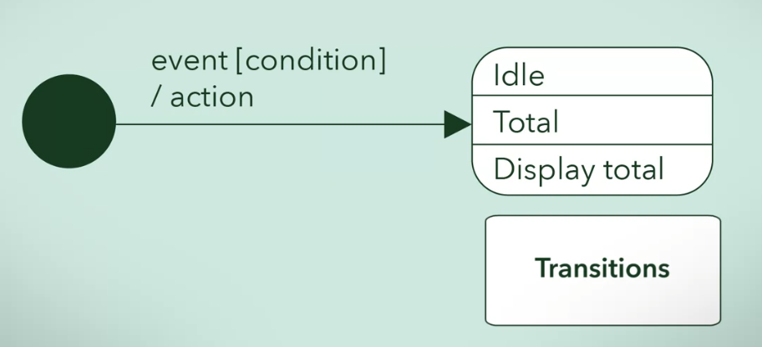

Another example of transition:

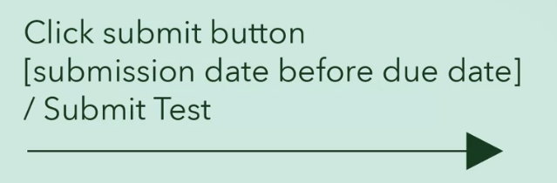

We can also have loops

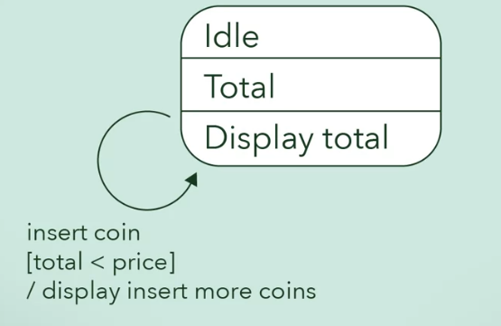

Full Example: Vending Machine

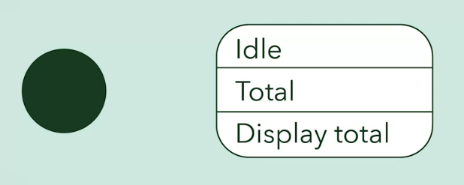

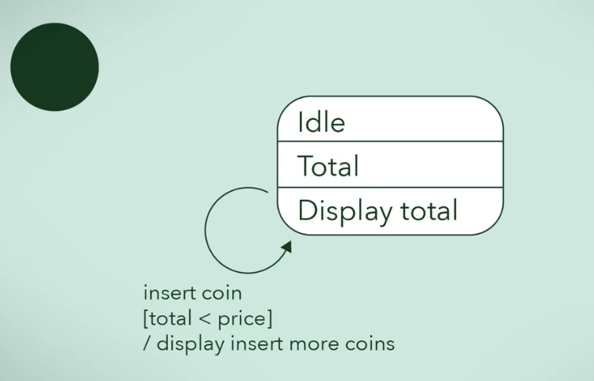

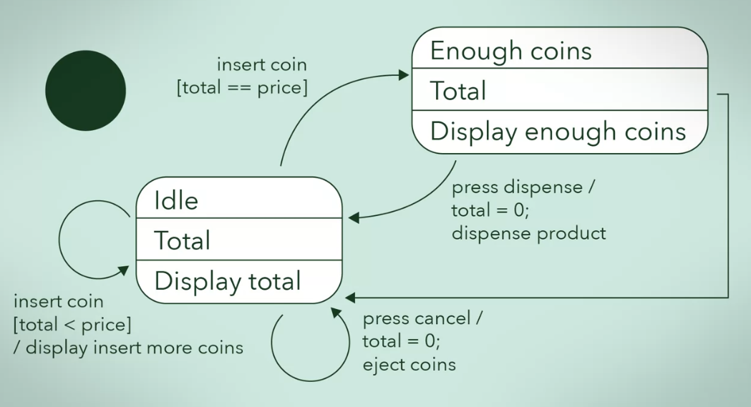

Termination

* Ending of states
* Not all have terminations, they may run continuously

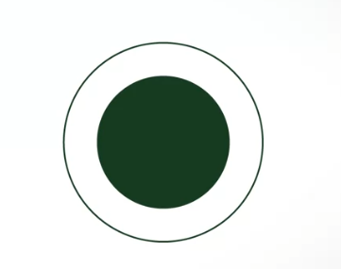

Summary

